Name : _________ ___... _________ ( )

Class : Primary 6 (emMprTy\_________.

CHIJ ST NICHOLAS GIRLS’ SCHOOL (PRIMARY)



Primary 6

Termly Assessment

25 February 2019

English Language

Paper 2 Booklet B

Duration of Paper (Booklets A & B): 1h 30 min

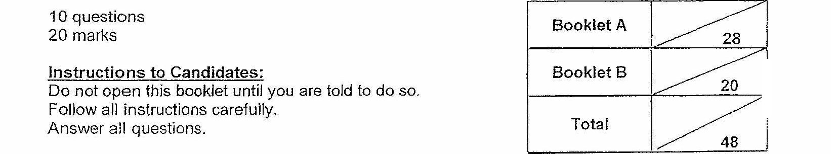

10 questions  
20 marks

Parenis Signature:

Tioga dren felict eerecy. ot pe tent ny Fp seg  
This bookie’ consists of & printed pages.